INTERNATIONAL DANCE TEACHERS' ASSOCIATION LIMITED
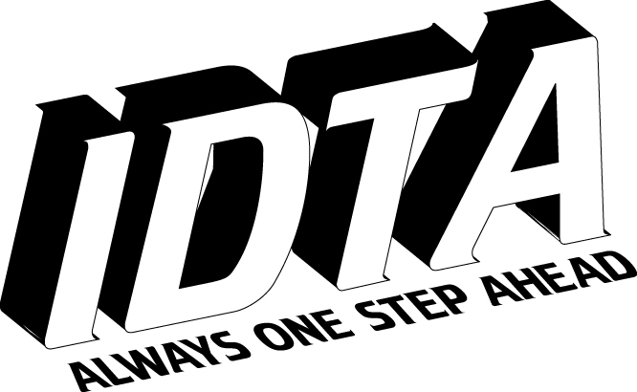
International House, 76 Bennett Road, Brighton, BN2 5JL

LATIN PROFESSIONAL EXAMINATION REPORT

Name Date Level

MARKS Demonstration Rumba Samba Paso Doble Jive Cha Cha Cha

Theory Rumba Samba Paso Doble Jive Cha Cha Cha

Teaching Ability

Remarks

Demonstration

Solo demonstration to music

Theory

Teaching Ability

__________________________________________________________________

