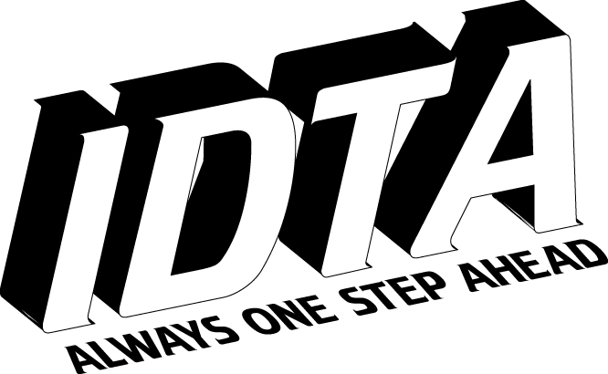
INTERNATIONAL DANCE TEACHERS' ASSOCIATION
International House, 76 Bennett Road, Brighton, BN2 5JL

SALSA DANCE TEACHERS DIPLOMA REPORT

Name Date Teachers Diploma

MARKS: Demonstration Theory Teaching Ability

DEMONSTRATION

THEORY

TEACHING ABILITY

Mark Examiner Chief Executive

Result (Pass 65, Commended 75, Highly Commended 85, Honours 90) (05/08)

